**DESIGN AND IMPLEMENTATION OF VSESC ELECTRONIC LOGBOOK MANAGEMENT SYSTEM**

VOCATIONAL SKILLS & ENTERPRENEURSHIP STUDY CENTER (V.S.E.S.C)

THE POLYTECHNIC IBADAN

**PREPARED BY:**

**ADEDAPO ABIODUN JOSEPH**

**2019235020021**

**A PROJECT SUBMITTED TO THE DEPARTMENT OF**

**COMPUTER STUDIES, FACULTY OF SCIENCE, THE POLYTECHNIC IBADAN**

**IN PARTIAL FULFILMENT OF THE REQUIREMENT FOR THE AWARD OF NATIONAL DIPLOMA IN COMPUTER SCIENCE**

**JULY 2022**

# CERTIFICATION

This is to certify that the project was carried out by **ADEDAPO ABIODUN JOSEPH** with matriculation number **2019235020021** under the thorough and constructive supervision of **MRS F.O. ADELODUN** of the department of **COMPUTER SCIENCE, THE POLYTECHNIC IBADAN.**

……………………………….. ………………..…………

**MRS. F.O. ADELODUN DATE**

Project Supervisor

……………………………….. ………………..…………

**MR. B. O. FADIORA**  **DATE**

Head of Department

# 

# DEDICATION

I dedicate this project to God Almighty my creator, my strong pillar, my source of inspiration, wisdom, knowledge and understanding for seeing me throughout my stay in The Polytechnic Ibadan. He has been the source of my strength throughout this program and on His wings only have I soared.

# 

# 

# ACKNOWLEDGEMENT

This research paper is made through the help of many people who include my parents, family and friends. Especially, please allow me to acknowledge with gratitude the following significant advisors and contributions. My special gratitude to my supervisor **MRS. F.O. ADELODUN** and head of the department, **MR B. O. FADIORA** for their guidance, immeasurable correction and good supervision of this project.

Also, my gratitude goes to my qualified lecturers: **MR. EGBEDOKUN G.G.O, MRS. F.O. IBITOWA, MRS ONI, MRS. O.O. ORIOKE, MR. F.S. OMOTOSHO, MR. S.J. AGBOLADE, MRS. AJIBOYE,** and **MRS. GANIYU.**

Lastly, I really appreciate my parents in person of **MR & MRS ADEDAPO** for their support and encouragement.

# ABSTRACT

This project work investigates an electronic logbook for Student’s Industrial Work Experience Scheme was designed to minimize the problems associated with the paper logbook such as susceptibility to manipulation or forgery, wearing, and storage problem and retrieval problems. An industrial supervisor is also expected to monitor the student’s weekly progress of work and append his signature for works actually done by the student.

To ensure that the aim of EED is achieved, a school-based supervisor is also expected to monitor the student's progress by visiting his place of primary assignment at regular intervals, and by the end of the exercise, a report is usually sent to the ITF office for verification and necessary documentation and payment of those who participated in the exercise. Each student uses a logbook to keep record of his/her experiences.

Traditionally, a logbook is a record of an event or events such as ship’s navigation, air flight, inventions, teachers’ events in the classroom etc. logbooks have been in existence since the invention of ships and the need for navigation came into existence. Today’s logbooks have diverse uses since all aspects of human endeavor need a form of reference or storage media.

However, with the advent of ICT and the internet the ways of doing things have changed.  An electronic logbook is a computer-based software for recording (logging) states, events or simply conditions used for complex machines like aircraft, nuclear plants, particle accelerators, various areas on board ships replacing paper-based logbooks etc.  An electronic alternative to record key navigation, engine watch, port calls and other operational activities on board vessels of all sizes.

.

**TABLE OF CONTENTS**

TITLE PAGE ……………………………………………………………………………….…….0

CERTIFICATION …………………………………………………………………………...……i

DEDICATION ……………………………………………………………………………………ii

ACKNOELDGEMENT ……………………………..…………………………………………...iii

ABSTRACT ……………………………………………..…………………….…………………iv

TABLE OF CONTENTS ………………………………………..….….………..……………..…v

CHAPTER ONE …………………………………………………….………………….…………1

1. INTRODUCTION ………………………………………….………………..……………1
   1. INTRODUCTION ………………………………….……………..………………………1
   2. STATEMENT OF PROBLEM …………………….……………..………………………5
   3. JUSTIFICATION OF STUDY …………………….…………..…………………………6
   4. AIM AND OBJECTIVES ………………………….…………..…………………………6
   5. SCOPE OF STUDY ………………………………..…………..…………………………6
   6. DEFINITION OF TERMS …………………………………..……………………………7

CHAPTER TWO ……………………………………………………………………….…………8

1. LITERATURE REVIEW ………………….….…………………………….……………8
   1. BACKGROUND OF STUDY ……………………………………………………………8
   2. RELATED WORKS ……………………………………………….……………………13
   3. ELECTRONIC LOGBOOK …………………………………………..…………………15
   4. ADVANTAGES OF ELECTRONIC LOGBOOK ……………………....………………17
   5. CURRENT METHOD IN USE ………………………………………….………………19
   6. APPROACH TO BE USED IN THIS STUDY …………………………..………………19

CHAPTER THREE ………………………………………………………………..……….……21

1. SYSTEM INVESTIGATION AND ANALYSIS ………………………...…….……….21
   1. BACKGROUN INFORMATION ON CASE STUDY ………………….………………21
   2. OPERATION OF EXISTING SYSTEM ………………………………..………………22
   3. ANALYSIS OF FINDINGS …………………………………………….………………22
   4. PROBLEM IDENTIFIED FROM THE ANALYSIS …………….…….……………….23
   5. SUGGESTED SOLUTION TO PROBLEM IDENTIFIED …………….………………24

CHAPTER FOUR ……………………………………………….………………..…..…………25

* 1. SYSTEM DESIGN ……………………………………………………..…..……………25
  2. OUTPUT DESIGN ……………………………..…………………………..……………25
  3. INPUT DESIGN ………………………………..………………………………..………28
  4. PRPOCESS DESIGN ……………………………....……………………………………32
  5. STORAGE DESIGN ……………………………….……………………………………34
  6. DESIGN SUMMERY ……………………..……….……………………………………37

CHAPTER FIVE ……………………………………………..………….………………………40

* 1. SYSTEM DEVELOPMENT AND IMPLEMENTATION ………..……………………40
  2. PROGRAM DEVELOPMENT ACTIVITY ………….…………………………………40
  3. PROGRAM TESTING ………………………………..…………………………………40
  4. SYSTEM IMPLEMENTATION ……………………..…………………………………41

CHAPTER SIX ………………………………………………....………….……………………42

1. SYSTEM DOCUMENTFATION …………………….…………………………………42
   1. FUNTION OF PROGRAM MODULES ………………..………………………………42
   2. USER MANUAL ……………………………………….….……………………………42

CHAPTER SEVEN …………………………………….……….…….…………………44

* 1. SUMMERY, CONCLUSION AND RECOMMENDATION ….………………………44
  2. SUMMERY …………………………………………….……..…………………………44
  3. CONCLUSION ………………………………………….………………………………44
  4. RECOMMENDATION …………………………………………………………………45

REFERENCES ………………………………………………………...…………..…………….46

APPENDIXES …………………………………………………………….…………………….49

APPENDIX A …………………………………………………………….....……….………….49

SYSTEM FLOWCHART ……………………………………………………...………………..49

APPENDIX B …………………………………………………………………………..………..51

SOURCE CODE …………………………………………………………….…………………..51

APPENDIX C …………………………………………………………………..……….………58

SAMPLE INPUT …………………………………..……………………………………………58

APPENDIX D …………………………………..…………………………………………….…60

SAMPLE OUTPUT …………………………….……………………………………………….60

# CHAPTER ONE

**1.1 INTRODUCTION**

The Centre was established in compliance with the Federal Government's initiative through NBT that all tertiary institutions in Nigeria must establish Entrepreneurship Development Centers (EDC) to solve graduates unemployment crises by ensuring that they acquire functional entrepreneurial skills, desirable work habit in addition to their formal education which will enable them to be self-reliant, self-employed and productive members of the society. To this end, Vocational Skills and Entrepreneurship Study Centre (VSESC) was resuscitated by the school management in June2008 after the extinction of the old Vocational Skills Improvement Unit (VSIU) to serve as community service and revenue generating outfit. This is a double barrel conception viz: skill acquisition programme and entrepreneurship development of graduates of this institution. In fact, Vocational Skills and Entrepreneurship Study Centre (VSESC) is to ensure that all graduates of the Polytechnic, Ibadan are practically sound in at least one vocational/entrepreneurial skill before graduation so that they can be self-reliant, self-employed and employer of labour rather than job seekers.

The Vocational Skills and Entrepreneurship Study Centre (VSESC) is a new Directorate under the Vice-Chancellor’s Office.  It was established on 20th April, 2012. Vocational Skills and Entrepreneurship Study Centre (VSESC) is a skills training program designed to expose and prepare students of universities and other tertiary institutions for the Industrial Work situation they are likely to meet after graduation.  It is also a planned and structured program based on stated and specific career objectives which are geared towards developing the occupational competencies of participants (Mafe, 2009).  Consequently, the VSESC program is a compulsory graduation requirement for all Nigerian universities and polytechnics students offering certain courses. The Vocational Skills and Entrepreneurship Study Centre (VSESC) is the accepted training program, which is part of the approved Minimum Academic Standard in the various degree program for all Nigerian Universities.  The scheme is aimed at bridging the existing gap between theory and practice of Sciences, Agriculture, Medical Sciences (including Nursing), Engineering and Technology, Management, and Information and Communication Technology and other professional educational program in the Nigerian tertiary institutions.  It is aimed at exposing students to machines and equipment, professional work methods and ways of safeguarding the work areas and workers in industries, offices, laboratories, hospitals and other organizations.

Scientists and engineers traditionally kept paper logbooks of their experiments and inventions. The need for the logbook cannot be over emphasized. Scientists need to keep a record of their doings in order to remember and report what has been done. The logbook also gives a means of retracing past experiments and verifying their accountability. Searching logbooks can also determine who the first was to make a new discovery or invention. In most parts of the world, the first to invent rule is used for patents and a properly kept logbook is crucial for proving an idea is yours. Student and professional bodies use logbook on regular intervals, Altini etal (2010).

In less than twenty years the habits of logbook use have changed radically. Even though some scientists still solely use old fashioned paper logbooks many large scientific collaborations are already using electronic logbooks, wave tracks (2010).

The Vocational Skills and Entrepreneurship Study Centre (VSESC) is an industrial training program for undergraduate students of Nigerian universities and other higher institutions. It is a four-month training scheme in which students are attached to industries in form of extra-curriculum activity.

The Industrial Training Fund (ITF) was created in 1971 with the promulgation of decree 47 of 1971. ITF was charged with the responsibilities of manpower training and development in general, with the specific mandate to promote skills acquisition in Industry and Commerce. To this end, Vocational Skills and Entrepreneurship Study Centre (VSESC) was resuscitated by the school management in June2008 after the extinction of the old Vocational Skills Improvement Unit (VSIU) to serve as community service and revenue generating outfit. Before the advent of the Vocational Skills and Entrepreneurship Study Centre (VSESC), students studying practical courses especially in science and technology were being set out with little or no practical knowledge of their various courses of study. The VSESC program is a compulsory graduation requirement for all student of the polytechnic Ibadan and other higher institution in Nigeria. In preparation for this program, such students are required to visit the departments in their various institutions in charge of it in order for the department to prepare them for their vocational training.

They are also required to go in order to collect documents that they are to fill during the course of their vocational training. One of such documents is the Logbook. The logbook is a book that contains the daily activities done by the student during the course of vocational training. The student is required to fill the logbook daily and the student is also required to give it to the industry-based supervisor to sign and comment weekly and then at the end of the vocational program, the student is to submit it back to school. Each year, higher institutions spend a lot of money in order to print these logbooks, money that could be put into better use if the logbook application is put into place. The work of marking these logbooks by the lecturers is also made difficult, as for them to mark the logbooks they would have to wait until all students have finished their vocational training, be it 4 months or 3 months and this can be very cumbersome on the lecturers and would also take a lot of time.

Supervisors assigned to each department in most cases have to inspect each logbook submitted by the student at the end of the class. Due to the population of the student, supervisor accesses the students activity for the day, during this process a lot of time has been taken and with the stress involved supervisor becomes exhausted and a lot of time wasted. Due to this, supervisors tend to access the students just once or at most thrice leading to inadequate monitoring of students’ activities. When students are done after their Vocational Training at the end of the semester, they submit their VSESC logbook in hardcopy which can be prone to theft and also destruction by natural disasters. The study aims at developing an electronic logbook in the form of a website that would serve as a better alternative to the paper logbook system that is currently being used in the higher institutions in Nigeria.

The basic objectives of Vocational Skills and Entrepreneurship Study Centre (VSESC) embraces the following:

* To provide opportunities of applying their knowledge to real practice thereby making easier the college work.
* Enhance the job skills of all graduates of The Polytechnic, Ibadan, as a means to self-employment, self-sustaining, and self-sufficiency.
* To expose students to opportunities beyond the academic curriculum.
* To enable students to practice theory been taught at school and provide access to the production equipment not available in the school.
* To provide skillful experience to all students in the school of technologies, polytechnics and universities.
* To inspire students about their careers
* To provide more man power to industries.

Every student is expected to keep a record of her experience for the duration of the vocational skill period and submit such records to her supervisor in due time. An industrial supervisor is also expected to monitor the student’s weekly progress of work and append his signature for works actually done by the student. To ensure that the aim of VSESC is achieved, a school-based supervisor is also expected to monitor the student’s progress by assessing his activities at regular intervals, and by the end of the exercise, a report is usually sent to the Exams and Record for verification and necessary documentation of result. Each student uses a logbook to keep record of his/her experiences.

Traditionally, a logbook is a record of an event or events such as ship’s navigation, air flight, inventions, teachers’ events in the classroom etc. logbooks have been in existence since the invention of ships and the need for navigation came into existence. Today’s logbooks have diverse uses since all aspects of human endeavor need a form of reference or storage media.

However, with the advent of ICT and the internet the ways of doing things have changed. An electronic logbook is a computer-based software for recording (logging) states, events or simply conditions used for complex machines like aircraft, nuclear plants, particle accelerators, various areas on board ships replacing paper-based logbooks etc. An electronic alternative to record key navigation, engine watch, port calls and other operational activities on board vessels of all sizes.

## **1.2 STATEMENT OF THE PROBLEM**

The need for an electronic logbook for V.I.S.E.S.C cannot be over emphasized. For a student to gain the required knowledge from vocational training experiences, he/she must be well monitored to ensure that he/she does not just participate in the training scheme in fulfillment of its mandatory status, but also acquire relevant experiences. The lack of electronic logbook makes this nearly impossible since distance between interns and supervisors and the lack of access to good reference source hinders the actualization of the desired goals. The problems faced by the manual type logbook are resolved by the implementation of our electronic logbook system. It will bring an advanced means of recording events, monitoring students’ daily activities and progress in a much easier and efficient way. Due to the use of a database engines vsesc supervisors would be able to print student’s logbooks and easily access/stores student’s data.

## **1.3 JUSTIFICATION OF STUDY**

Implementation of VSESC Electronic Logbook system will replace conventional analog type, paper-based logbook board with digital logbook which would make supervision much easier. As has been stated in section 1.2, there are lots of problems with the traditional logbook that justify the quest for a better way of handling internship experience logbook. Perhaps the most outstanding of this reason is the bridging of the gap between supervisors and interns.

## **1.4 AIM AND OBJECTIVES**

**1.4.1 THE AIM OF THE STUDY**

The aim of the study is to design and implement an electronic logbook for Vocational Skills and Entrepreneurship Study Centre (VSESC)

**1.4.2 THE OBJECTIVES OF THE STUDY**

* To review and analyze the existing system
* To develop a software capable of logging students’ work entries in an electronic format.

## **1.5 SCOPE OF STUDY**

This project work is majorly focused on providing an electronic logbook, limited to the Nd2 student in the department of computer science.

## 

## **1.6 METHODOLOGY**

In the development of any project, a very important requirement is the gathering of data for the project. It uses the following method to gather the necessary and required data for development.

**Interview Method:** This has to do with carrying out one to one interview with those involved, particularly the Lecturers and students so as to know their opinion as regard to the existing system.

**Observation Method:** This involves self-observation from the research to understand the current system and identify the short coming of the system in order to design the new system.

**Documents and Records System:** This involves getting information from existing documents and records of research already done, in order to successfully design the new system.

**Focus Groups:** This involves the collection of data from several individuals who have something in common. The purpose of this is to add a collective view to the result of the data collected.

## 1.6 DEFINITION OF TERMS

### PHP:  PHP is an acronym for "PHP: Hypertext Preprocessor". PHP is a general-purpose scripting language especially suited to web development.

### HTML: HTML stands for Hyper Text Markup Language · HTML is the standard markup language for creating Web pages

### DBMS: Stands for "Database Management System." In short, a DBMS is a database program. Technically speaking, it is a software system that uses a standard method of cataloging, retrieving, and running queries on data.

### Database: A database is an organized collection of data, generally stored and accessed electronically from a computer system. Where databases are more complex they are often developed using formal design and modeling techniques.

### Administrator: A person who monitor the students that as submitted their logbook

### User: is the person that enters the activities he/she did for that day.

### Logbook: A logbook is a record of important events in the management, operation, and navigation of a ship. It is essential to traditional navigation, and must be filled in at least weekly. The term originally referred to a book for recording readings from the chip log that was used to estimate a ship's speed through the water.

### Electronic: Electronics is defined as devices run by electric power or the field of studying such items. An example of electronics are radios, computers, and televisions (physics). The study and use of electrical devices that operate by controlling the flow of electrons or other electrically charged particles.

# 

# CHAPTER TWO

## **LITERATURE REVIEW**

## **2.1 BACKGROUND OF STUDY**

Industrial training is a bridge from the classroom to the workplace. R. Akerejola (2004) defined industrial training as an opportunity to test skills, interests and career choices in real work situations while obtaining an edge on “inexperienced” job market competitors. The industrial training program has become a necessity for students to partake in order to complete their educational program, especially students of the Science, Engineering, and Technology disciplines. S. Osman et al, 2008 evaluated students in various areas which can be summarized into three main areas which are attitude, communication and work attitude before and after the industrial training program. The results showed that the average score of the students increased from 48% - 63% before the Industrial Training to 89% - 95% after the Industrial Training S. Osman et al., 2008. Over the years the industrial training has been very beneficial to students, J. A. Cannon (2009) noted that students see the industrial training as a means to land their first job, R. Hite  et al., (2010) found that students view internships as a valuable learning experience through which they receive an academic grade and also financial compensation. he advantages of Industrial Training include:

Industrial training provides a platform that renders practical knowledge of all they have been taught in school. Students are trained, tutored and mentored by trained and seasoned professionals. Industrial Training helps students to gain valuable work experience for some students this might be the first time of them in a working environment in the real world.

In this current world where “who you know” matters a lot, industrial training provides a platform for students to network with professionals who are years ahead of them. A lot of companies use industrial training as a means to recruit new staff. Industrial Training thereby provides job opportunities for students once they graduate.

To this end, Vocational Skills and Entrepreneurship Study Centre (VSESC) was resuscitated by the school management in June2008 after the extinction of the old Vocational Skills Improvement Unit (VSIU) to serve as community service and revenue generating outfit to bridge the identified gap between theory and practice in our tertiary institutions. Before the advent of the Vocational Skills and Entrepreneurship Study Centre (VSESC), students studying practical courses especially in science and technology were being set out with little or no practical knowledge of their various courses of study. The VSESC program is a compulsory graduation requirement for all the polytechnic ibadan students offering certain courses. In preparation for this program, such students are required to visit the departments in the institution in charge of it (which is VSESC center) in order for the department to prepare them for their industrial training. They are also required to go in order to collect documents that they are to fill during the course of their industrial training. One of such documents is the Logbook. The logbook is a book that contains the daily activities done by the student during the course of industrial training. The student is required to fill the logbook daily and the student is also required to give it to the industry-based supervisor to sign and comment weekly and then at the end of the industrial program, the student is to submit it back to school. Each year, higher institutions spend a lot of money in order to print these logbooks, money that could be put into better use if the logbook application is put into place. The work of marking these logbooks by the lecturers is also made difficult, as for them to mark the logbooks they would have to wait until all students have finished their industrial training, be it 4 months and this can be very cumbersome on the lecturers and would also take a lot of time. When students are done towards the end of the semester, they submit their VSESC logbook in hardcopy which can be prone to theft and also destruction by natural disasters. The study aims at developing an electronic logbook in the form of a website that would serve as a better alternative to the paper logbook system that is currently being used in the higher institutions in Nigeria.

Many higher and further education institutions now run Virtual Learning Environments (VLEs), with tools for course management, assessment and group working. Although they have been widely adopted, VLEs are limited in their support for new methods of teaching and learning such as problem-based learning, informal team working, and personal learning management. Nowadays, most learners are no longer confined to a single institution throughout post-school education. The availability of part-time courses, work-based learning and other informal learning activities all contribute towards the attainment of an individual’s learning goals. It is expected that people will continue to acquire new skills throughout their lifetime and build a transferable portfolio of competences JISC (2005a).

Another trend in tertiary education is towards small group collaborative learning. Students are expected to acquire competences in collaborative working and project management through team projects and group-assessed coursework. In recent years these have typically been mediated by online discussion and coordination. Learners and tutors may use a variety of informal collaborative tools such as newsgroups, weblogs and instant messaging alongside the tools that are provided by the institutional VLE. This increases the number of logins required by the users as they move from one system to the next, presenting a major challenge to search and retrieve relevant learning materials. In addition, students may use a wide range of overlapping Personal Information Management (PIM) tools such as calendars, contact lists and email, running on computers and mobile phones. The information across these devices and applications needs to be consolidated into one place and directed towards support for learning Corlett, D. & Sharples, M. (2004).

A third trend is the requirement on tertiary education to support students in maintaining learning portfolios and personal development plans, as aids to reflective learning and as transferable records of achievement. In science and engineering disciplines there is a long tradition of using paper-based logbooks to record and review learning activities. A problem with the paper-based logbook is that much learning activity is now carried out online, through email, web browsing and word processing. Currently, students have to add these online activities to the paper logs by printing out the documents or transcripts of email and pasting them into the logbook. Activities such as interactive software design and video production can only be included in the logbook as CDROMs or as references to online websites. New designs for virtual learning environments are reflecting these educational changes, adding tools for collaborative document production, student project management and multimedia presentation, as well as integration with content management, student administration, and examination. However, they are still designed around the structure of the curriculum, rather than the needs of the individual student. Even if the learning can be captured and presented online, this is a taxing process. Students must save and organise their online activities from a variety of sources including tasks carried out on the VLE, email correspondence, and material they may have designed in the form of documents, presentations, web pages, video, audio, and computer programs Corlett, D., (2005).

The continuous quest to bridge the gap between industrial work practices and the knowledge gained in institutions has remained the major driving force in supporting Internships. This as a result of the fact that students graduate with little or no working knowledge of the industry practices there by finding it difficult to cope once employed (Abdullahi, 2009). This is especially true for science and technical oriented courses. Therefore, the need to acquire the relevant experiences from industries before graduating from institutions becomes a necessity before graduating from institutions. Due to this fact in June 2008, The Polytechnic Ibadan developed an internship program, Vocational Skills and Entrepreneurship Study Centre (VSESC) to be headed and managed by The Polytechnic Ibadan. Also Oyeniyi, (2012) shows that graduates demonstrated the significant impact of the scheme in terms of skills acquisition and utilization; research also shows that students, having participated in the scheme, show acceptability of the scheme and encourage continuous support of it by the relevant bodies and Government (Nse, 2012). However, the scheme is still faced with several challenges that inhibit the full realization of the objective of the scheme. Among many are challenges associated with proper supervision and coordination of the process, non-compliance by industries to accept such students (Nse, 2012); fuzzy job specification for the different courses, students’ interest in participating in a skill oriented projects, and inadequate supervision (Olabiyi and Okarfor, 2012); other challenges included finances, students’ placements, irregular academic calendars (Ojokulu et al., 2015). There are lots of problems with the traditional logbook that justify the quest for a better way of handling internship experience logbook. Perhaps the most outstanding of this reason is the bridging of the gap between supervisors and interns. The Nigerian academic curriculum has witnessed a lot of disruptions in recent times mostly because of massive industrial actions to drive home a demand. Only recently, the Nigerian universities, Polytechnics and Colleges of Education embarked on an over six month’s nationwide strike. The students who were undergoing IT training at that time will have to depend solely on their industry supervisor and instincts. With information technology and the gains associated with it, most nation of the world has successfully migrated from the paper method of keeping records. It is therefore a worthwhile venture to affirm the already introduced practice of modernity since we have much to learn/do if we are to be able to be able to rub shoulders with our counterparts elsewhere. Presently, an internship student needs to make their logbook in a physical paper which is only visible for him or herself view. Then after their internship program is done, they need to submit the logbook to the lecturer for grade and graduation purpose. Therefore Supervisors or instructor have to wait till the end of the training scheme to assess the performance of the students. As a result of this problem, supervisors find it very difficult to monitor the progress of the student regularly. It is against this backdrop that this study, sort the way to bridge the gap between the student on IT and the supervisors.

## **2.2 RELATED WORKS**

1. Integrated Electronic Logbook designed by Macauley Hoyt, Brandon Lee, Taylor Rodenhus, and John Trainor *(2018).*

All cadet authors are members of the Department of Systems Engineering at the United States Military Academy. They will commission in May of 2018 and look forward to a career as officers in the United States Army. Each cadet has a solid background in the systems engineering field and was chosen to assist the Project Management Unmanned Aerial Systems (PMUAS) team at Redstone Arsenal in creating an Integrated Electronic Logbook (IELB) for the Shadow drone platform.

1. The current Universal Ground Control Station (UGCS) for US Army Shadow and Gray Eagle drones require manual input of all flight records into the flight record system. The purpose of creating an IELB is to create a more efficient system to accurately record flight data for Unmanned Aerial Systems (UAS). In utilizing a combined systems approach, this capstone project develops a concept of operations (CONOPs) for PMUAS at Redstone Arsenal to guide the development of an IELB for the Shadow drone platform. The intent of this paper is to provide the background information necessary in generating a CONOPs for the IELB.
2. SIWES MANAGEMENT SYSTEM: Web Technology Approach Case Study of Faculty of computer science and Information technology

The system was developed using the laravel framework with HTML, CSS, JavaScript and PHP as the languages. The major problems covered are Student to supervisor allocation, SIWES place Selection, SIWES place recommendation, logbook management and web based chat between the users. In the course of implementation, the system was uploaded online under the sub domain siwes.fcsit.net. At the end of the project we found that more than 90% of the systems associated to the SIWES programme are web based and it is recommended for future studies to build mobile applications. Also, the data stored can be used to allocate project supervisors using similarity in their skills. We further recommend the utilisation of the system as it will bring efficiency and effectiveness in the management of SIWES students in the faculty.

1. A host of other institutions in Nigeria (UNIOSUN, 2015; UNIZIK, 2014; UNILAG, 2015; UNILORIN, 2016) have also implemented SIWES portals to enable them manage the processes efficient. These systems, to the best of our knowledge, have not being published on any literatures. These solutions, as described above would only help in advancing the degree of the realization of the overall SIWES objectives to some extent due to the limitations associated with the researches. They include:

* These systems are implemented and managed by particular institutions. This implies that only such institutions with such system actively oversee the SIWES processes; ITF and Industries do not take part in the processes. Thus, no collaboration between the elements that must collaborate to ensure the success of the scheme
* Being web-based systems, they do not enjoy the benefits cloud-based systems and services offers which in part may be accountable for limitation of the collaboration.

Following the limitations of existing systems, a cloud-based solution that would enhance collaborative management and real-time supervision of students on SIWES as well as allowing students to report their daily activities. It also allows students to submit their account details for payment of allowances by the ITF which has been a concern hitherto.

1. Ugwuanyi and Ezema (2010) consider it as a co-operative industrial internship programme that involves institutions of Higher learning, industries, the Federal government of Nigeria, industrial training fund, National Universities Commission, National Board for Technical Education and National Commission for Colleges of Education in Nigeria. They further noted that it is a core academic requirement that is compulsory at the National Diploma level that is scheduled in the National Board for Technical Education curriculum. Mafe (2009) gave a breakdown by stating that SIWES covers about 60 programmes in universities, 40 programmes in polytechnics and about 10 programmes in colleges of education in Nigeria. He further noted that students often mistakenly and commonly refer to SIWES as Industrial Training (I.T) whereas I.T is generic, while SIWES is a form of co-operative or industrial training operated in Nigeria. The Industrial Training Fund Policy Document No.1 (1973) presented the objectives of SIWES to include; 1. to provide an avenue for students in institutions of Higher learning to acquire industrial skills and experience in their course of study; 2. to provide students an opportunity to apply their knowledge in real work and actual practice; 3. to make transition from school to world of work easier and to enhance students contacts to later job placement;

## **2.3 ELECTRONIC LOGBOOK**

The post-medical education training board in the United Kingdom defines assessment as, "The process of measuring an individual's progress and accomplishments against defined standards and criteria, which often include an attempt at measurement. The purpose of assessment is to make a judgment about mastery of skills, to ensure improvement over time, to arrive at some definitions of strengths and weakness, to rank people for selection or exclusion, or perhaps to motivate them."Balasundaram I et al., (2010) Ongoing and regular formative assessment with comprehensive summative assessment is essential to follow students' progress. Anziani H. et al., (2008), Logbooks are part of continuous assessment for feedback to students that observe the outcomes of Industrial Training Patil NG et al., (2002) and are sometimes used as a tool for individual student guidance, and evaluation of programmes. Denton G.D et al., (2006) Logbooks provide feedback to the students about their progress, allow correction of weaknesses, and guide them on the path to achievements. Hunter R.D et al., (2005) Logbooks are developed in accordance with the core curriculum of any course. The students record their professional, Industrial experiences based on the objectives in the logbooks. Luke C. et al. (2009) Logbooks facilitate and monitor students' learning, provide a reward system based on competition among peers, encourage immediate and ongoing interaction between the tutors and the students, provide continuous and objective assessment, provide a feedback loop for the evaluation of learning activities validate the procedural experience at advanced training levels, and involve training centers. Despite the benefits of logbooks, their usage in Industrial Training is not well established. Traditionally, logbooks are used simply as means for students to document their activities. Unfortunately, trainees are not required to report outcome data and there is no verification process other than to ask the supervisors whether the logbook has been viewed. The data currently required for trainee logbooks do not prepare the trainees for a lifetime of professional audit. Since students are the main stakeholders in an appropriate logbook design, the aim of this study was to create an online logbook for students undergoing an industrial training, so as to make it easier for them to record their progress as regards their activities in the field. Electronic logbook for Vocational Skills and Entrepreneurship Study Centre (VSESC) was designed to minimize the problems associated with the paper logbook such as susceptibility to manipulation or forgery, wearing, and storage problem and retrieval problems. An industrial supervisor is also expected to monitor the student’s weekly progress of work and append his signature for works actually done by the student. To ensure that the aim of VSESC is achieved, a school-based supervisor is also expected to monitor the student's progress at vsesc center at regular intervals, and by the end of the exercise, a report is usually sent to the school management for verification and necessary. Each student uses a logbook to keep record of his/her experiences.

Traditionally, a logbook is a record of an event or events such as ship’s navigation, air flight, inventions, teachers’ events in the classroom etc. logbooks have been in existence since the invention of ships and the need for navigation came into existence. Today’s logbooks have diverse uses since all aspects of human endeavor need a form of reference or storage media.

However, with the advent of ICT and the internet the ways of doing things have changed.  An electronic logbook is a computer-based software for recording (logging) states, events or simply conditions used for complex machines like aircraft, nuclear plants, particle accelerators, various areas on board ships replacing paper-based logbooks etc.  An electronic alternative to record key navigation, engine watch, port calls and other operational activities on board vessels of all sizes.

## **2.4 ADVANTAGES OF ELECTRONIC LOGBOOK**

This qualitative study showed that the advantages of logbooks are objective assessment, self-evaluation and better accountability. But for improving the quality of learning, reliability of assessment and to remove the limitations, it is essential to change the structure of the logbooks. Also, objectives of courses should be part of the logbooks, and all tutors need to use them, uniformly Giorgi A (2008). Logbooks can be used for assessing Industrial Trainee competences and can help lecturers to assess students objectively Morse J.M (2005). By providing students with logbooks that list objectives, the summative assessment can be more objective, can encourage the students to develop responsibility by providing opportunity for self- assessment. The students found the manual logbook time consuming. Various types of electronic logbooks have been developed to reduce the time for reports, portability and adaptability for other uses. Nowadays, a number of trainees use free or inexpensive database for desktop, laptop or personal digital assistance (PDA)-type computers to record their own procedural logbooks. Wimmers P.F (2006), the e-logbook is a modern logbook that allow data input easily and quickly. Therefore, such advancements must be made use of while developing logbooks for trainees in industrial training. Very few studies have been done to determine the accuracy of the documentation of students' experience in logbooks. It seems difficult to create logbooks which are simple to use, and still yield reliable and valid data Dennick R. (2000). Good assessment should be valid, reliable, educational, acceptable and feasible. Similar to the current study, other researchers have also shown that validity and reliability of logbooks remain a challenge. For improving the reliability of logbooks, it has been suggested to employ inter-observers and/or multi-tutor assessment methodology. One of the findings of the study was that the students found the logbooks stressful. Some studies suggest that interactive logbooks improve communication between the lecturers and the students. The tutors then assigned a grade to students who had been involved in presentations or demonstrations, and assessing the student's performance. Throughout each teaching block, the logbook process will identify students who would benefit from counseling. Therefore, it is better to improve interactive logbooks that develop friendly communication between the lecturers and the students. As students become less responsible for both recording and charting their own clinical experiences, their anxiety would decrease. In parallel with the present study, some studies consider that current logbooks are only a record of work that students carried out, and not of the outcome of their performance. Therefore, logbooks do not adequately prepare trainees for a lifetime of effective audit and self-learning.

Some of the advantages of e-logbook are as follows:

* ➢Reduce HOS (Hours-of-Service) Violations
* ➢Reduce Errors and Improve Accuracy
* ➢Increased Safety input of records
* ➢Improve Students’ Behavior towards filling of daily activities
* ➢Breeze through Inspections
* ➢More Functionality on the Students’ Records

VSESC enabled students to acquire some competencies/skill. However, a close observation shows that students gained competencies/skills mostly in traditional librarianship areas while they did not fare so well on competencies/skills that lean towards information and communication technology (ICT) and personal skills. While acquisition of traditional competencies/skills is highly important.

## **2.5. CURRENT METHOD IN USE**

In managing education in Nigeria, the system requires a well-structured and derivable information as a bases for electronic submission of logbook. The system in use to design to implement a computerized information tracking system so as to eradicate the inherent problems encountered by industrial training fund. The study of the usability of electronic logbook for interns is of paramount importance considering the number of problems that will be solved in the event of a successful adaptation of such logbooks. Some of the problems associated with paper logbook are already stated in the problem statement.

Everything is going digital with the advent of ubiquitous computing and the Nigerian society should not be an exception. To change a society requires a change in the manner of perception and handling of issues by the academic community.

## **2.6. APPROACH TO BE USED IN THIS STUDY**

The approach to be used is implementing a web-based software that will make submission of logbook easier and faster to all users. The top-down approach was used for the software development and the tools used for this project are HTML, CSS, BOOTSTRAP, PHP and SQL Server. Every student is expected to keep a record of her experience for the duration of the training period and submit such records to her department for grading.

# CHAPTER THREE

## **SYSTEM INVESTIGATION AND ANALYSIS**

## **3.1 BACKGROUND INFORMATION ON CASE STUDY**

The polytechnic of Ibadan is a public institution established by 1970 as a successor to the erstwhile Technical College, Ibadan under the provision of a principal Edict cited as The Polytechnic Ibadan Edict 1970. The primary function of the Polytechnic Ibadan is to provide for students practical training and development of technics in Applied Science, Engineering, Environmental, Science and Commerce. The Polytechnic has been producing majority middle level man power that has been making valuable contributions to the social and economic development of the country.

The Polytechnic, Ibadan uses the manual collection of logbooks and most times check on student in their vocational skill (vsesc) center physically. The primary focus of the Polytechnic is training that is practical oriented. The institution has been performing this function creditably well for over thirty years. The graduates of the Polytechnic, Ibadan are found in almost all areas of endeavour all over the country and even outside the country. Some of them have become captains of industries and commerce. By the amendment to the principal Edict of the Polytechnic which came into force on 17th March, 1987, four Satellite Campuses of the Polytechnic were created. They took off during 1981/82 session and were sited at Eruwa, Saki, Iree and Esa-Oke. Each of the Campuses is headed by a director who is responsible to the Rector for the administration and discipline of the campus. However, with the creation of Osun State, the campuses at Iree and Esa-Oke have become the property of Osun State Government and are today known as Osun State Polytechnic Iree and Osun State College of Technology Esa-Oke.

The Polytechnic, Ibadan. Computer Science department and even other institution in Nigeria was initially using the Paper type logbook system before the invention of this current electronic logbook system in order to reduce all the stress of keeping a paper-based logbook before student can record his daily activities each day in his/her vsesc center. So, the software will create the access for each student and the vocational skill coordinator in charge for easy submission and documentation.

## 

## 3.2 OPERATION OF THE EXISTING SYSTEM

## The Existing system uses manual collection of logbooks which brings a lot of stress for the lecturer in charge to take attendance and make comments on task submitted by the students. So, the way they operate all these processes are called pen on paper operation which consume time and human labour another disadvantage of the existing system is that manual collection of logbooks which can be misplaced.

## 3.3 ANALYSIS OF FINDINGS

Analysis of findings is an approach taken to acquire data about a specific or subject with the aim of analyzing and synthesizing the analysed data to come up with a better system. The researcher used different techniques in data collection in this research and they include: interview, examination of existing documents, internet browsing and use of questionnaires. A set of well-articulated questions were used to interview a number of persons. During the investigation, some documents used for drafting the electronic logbook were examined. Some of them include:

i. List of course related skills and practical courses offered by the vsesc organization.

ii. List of existing organizations and their carrying capacity.

iii. List of periods or intervals. The internet is the largest pool of information where virtually everything can be found. The researcher in addition to examining existing documents equally used the internet. Some relevant and related documents were downloaded. The researcher used the questionnaire to take conclusion on how the user interface will be. It was developed using Google Forms.

**a. ANALYSIS**

In this section, thorough studying and analysis of the gathered data and fact were done on the existing system. In the Polytechnic Ibadan, vsesc logbook is done by

1. Payment of EED fee on the school portal
2. Registration for EED at the vsesc centre by each student from officer of each department so as get a requirement of getting the manual logbook.
3. Submitted documents which are signed by the vsesc organisations are taken by the student to the various department under vsesc for collection of their paper logbook and all other related documents like the practical manual, etc.
4. At the end of receiving inputs from students and coordinators alike, the school then allocate students to their various department depending on their area of interest (skill).

## 

## **3.4 PROBLEMS IDENTIFIED FROM ANALYSIS**

In today’s world of connectedness, it is important to keep pace with time because people are becoming accustomed with technology and also with the increasing competition in the market and to stand on the present environment of the modern world. The traditional way of filling logbooks is quite tedious and people tend to encounter a lot of problems which may include the following drawbacks:

1. It generates a lot of paperwork and is very tasking.
2. Fast report generation is not possible.
3. Tracing a student’s information is difficult.
4. Information are not properly maintained e.g., vsesc center where students take training etc.
5. No central database can be created as information is not available in database but only on a pen to paper method.
6. Inadequate knowledge of record keepers on the use of information from records.

## **3.5 SUGGESTED SOLUTIONS TO PROBLEM IDENTIFIED**

The provision of a concrete, prompt and effective web based Vsesc electronic logbook system will go a long way in solving the problems of the existing system highlighted above.

# CHAPTER FOUR

## **SYSTEM DESIGN**

System design involves the analysis, which covers the new specification of the proposed solution, the design, which covers the development and interfacing of the different modules that makes up the entire system and configuration of the necessary hardware and software components to support one’s solution architecture. In the same vein, system design is to deliver the requirements as specified in the feasibility study. The main objectives of system design are; practicality, efficiency, cost, flexibility and security.

## **4.1 OUTPUT DESIGN**

**a) Reports to be generated**

1. User List *(Admin)*
2. All Users Activities *(Admin)*
3. Student Filled Logbook
4. Student Profile

**b) Screen forms of reports**

1.

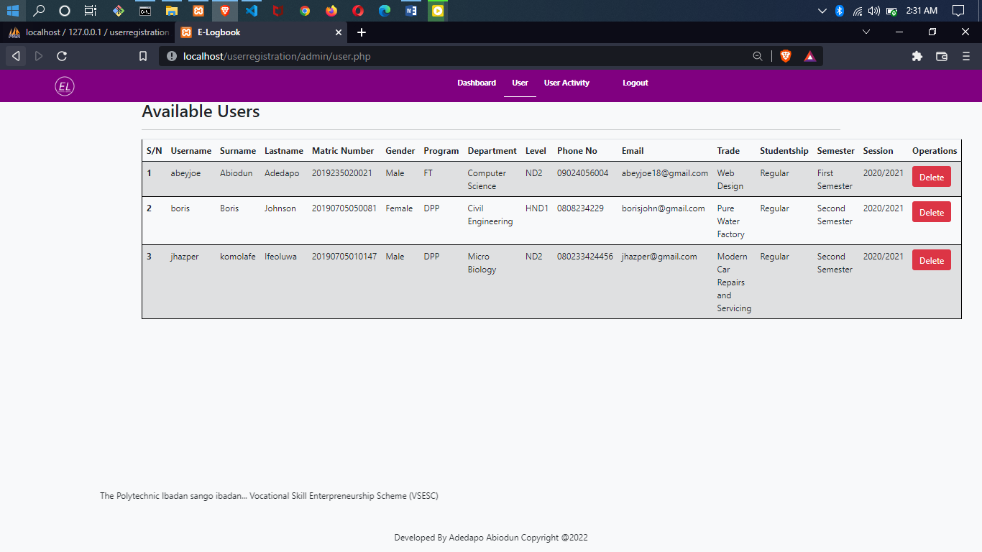

**Fig. 4.1 Users List *(Admin page)***

2.

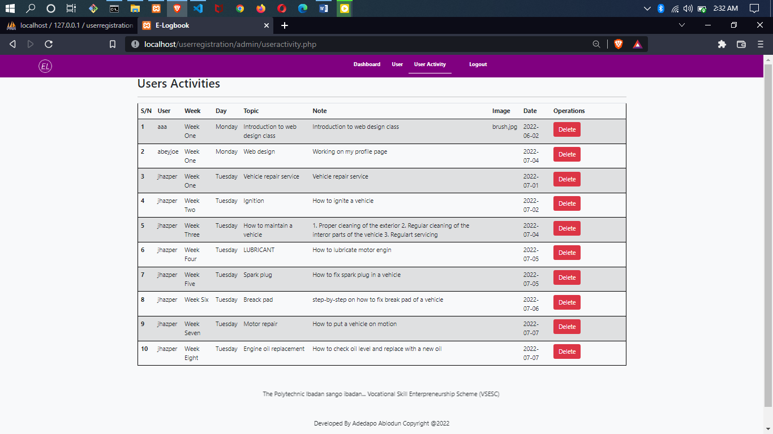

**Fig. 4.2 All User Filled Logbook *(Admin)***

**3.**

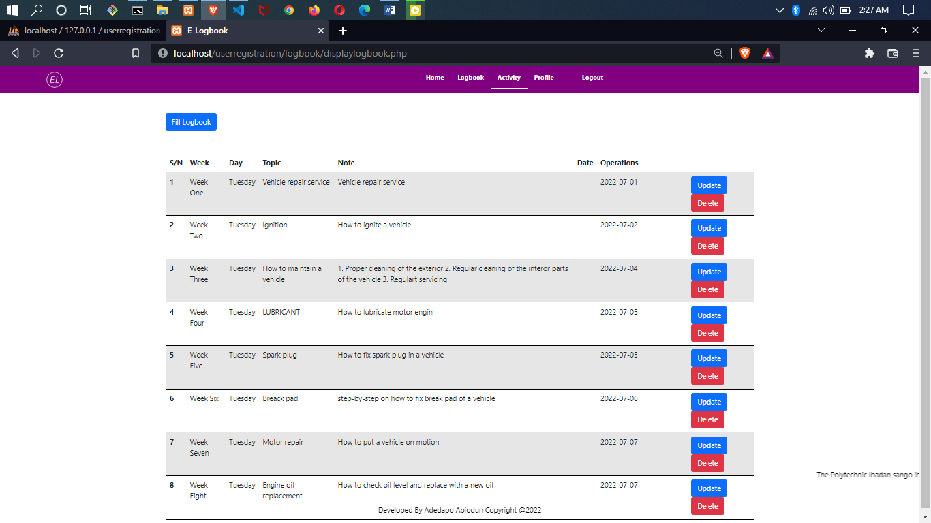

**Fig. 4.3 Student Filled Logbook**

**4.**

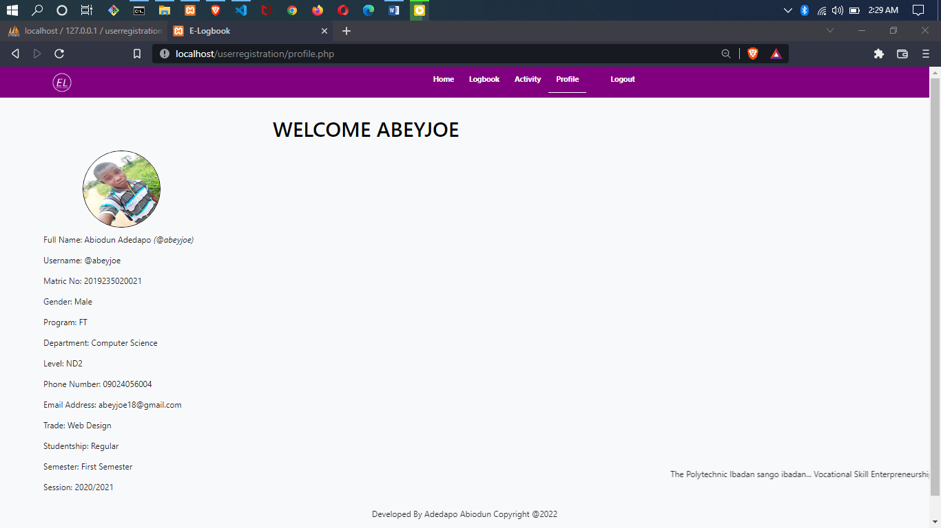

**Fig. 4.4 Student Profile**

**c) Files used to produce reports**

* admin/user.php
* admin/useractivity.php
* logbook/displaylogbook.php
* profile.php

## **4.2 INPUT DESIGN**

These are the data fed into the system for the purpose of manipulation, retrieving, recording and maintenance. The devices needed for input are keyboard and mouse.

1. **List of input items required**

Registration Page

* Surname
* Last Name
* Username
* Password
* Matric Number
* Gender
* Program
* Department
* Level
* Phone Number
* Email Address
* Profile Picture
* Trade
* Studentship
* Semester
* Session

Login Page

* Username
* Password

Logbook Form

* Select Week
* Select Day
* Topic
* Note
* Date

1. **Data capture screen forms for input**

1.

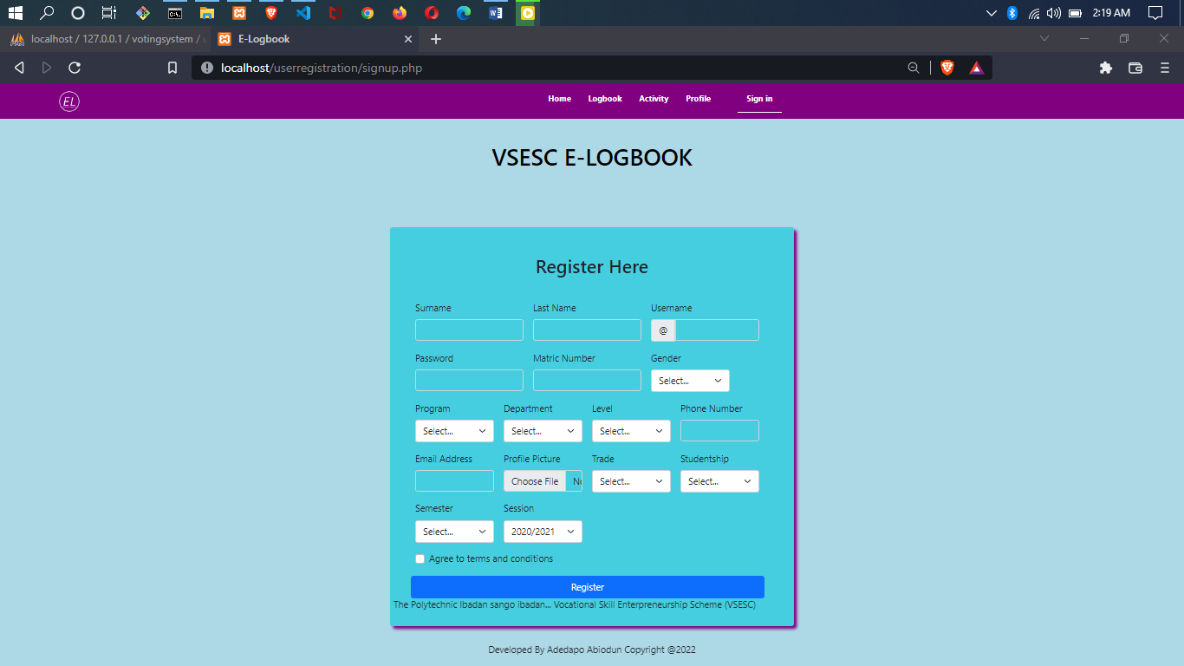

**Fig. 4.5 Signup page**

**2.**

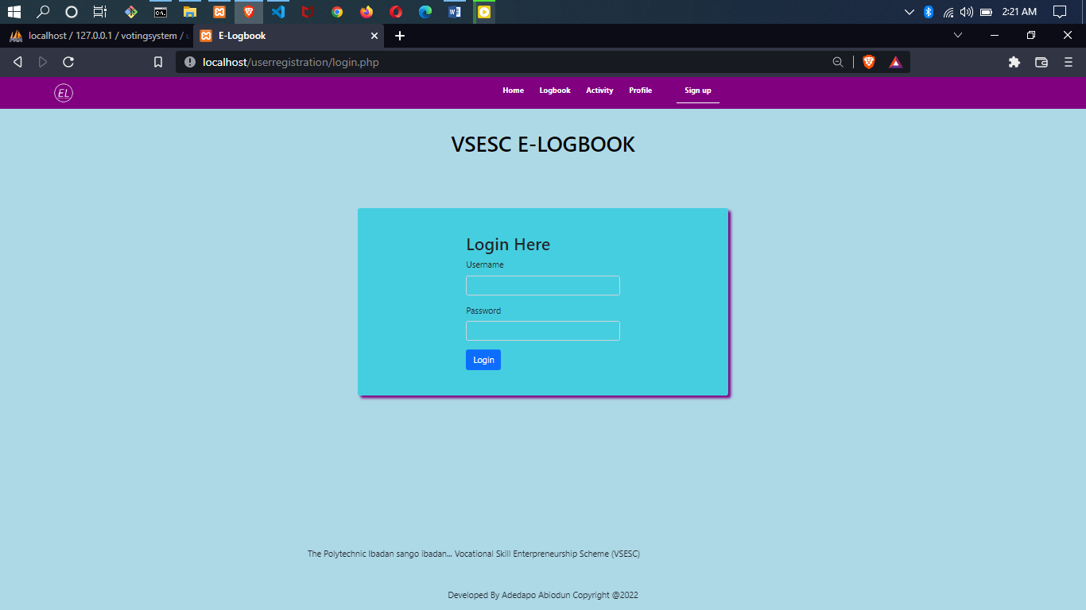

**Fig. 4.6 Login Page**

**3.**

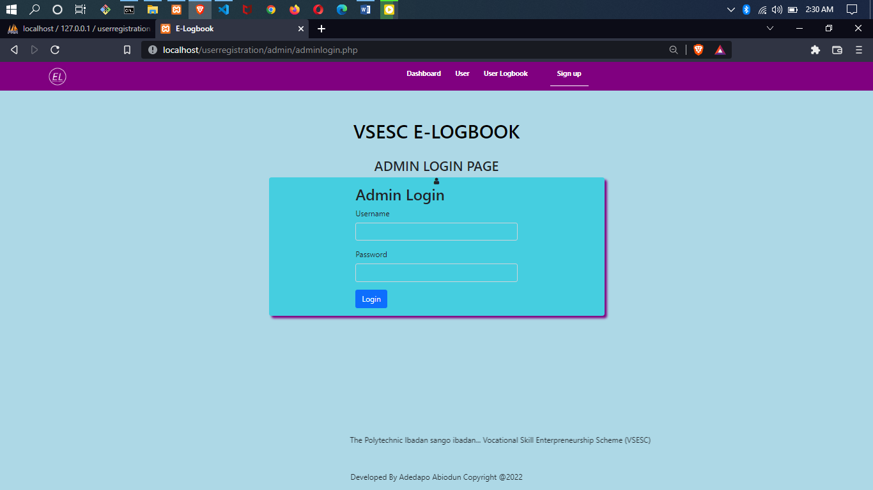

**Fig. 4.7 Login Page *(Admin)***

**4.**

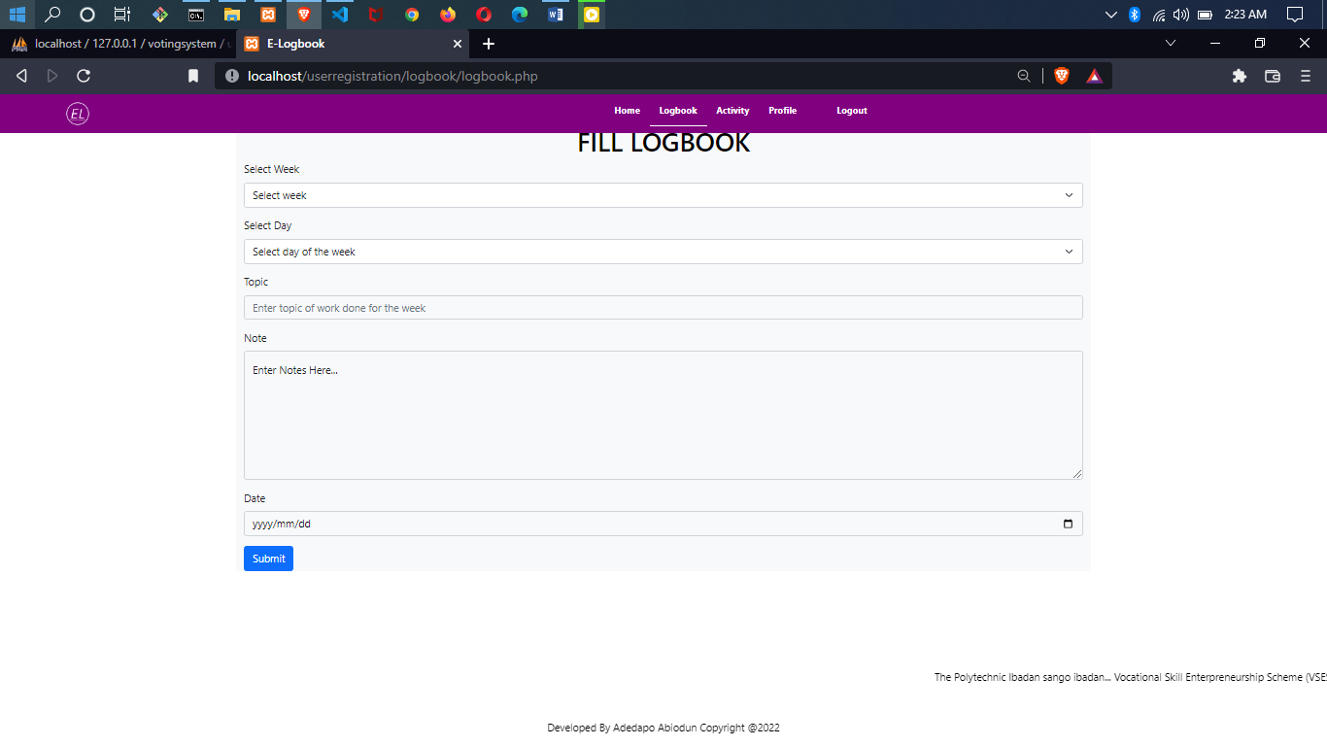

**Fig. 4.8 Fill Logbook Page**

**c) Files used to produce reports**

* Signup.php
* login.php
* admin/adminlogin.php
* logbook/logbook.php

**d) Files used to retain inputs**

For the new system, we do not need new files or any other form of storage for saving our inputs. MySQL database is used in saving all incoming data.

## **4.3 PROCESS DESIGN**

This system defines the procedures to take towards generating an efficient output. The process design linked every module together to produce a desired output.

**a) List of all programming activities necessary**

Various programming activities are performed to successfully build the new system these activities include:

* The design of the database used.
* Design of the client-side script i.e., JavaScript which enables efficient interaction between the user and the GUI application of the new system.
* HTML coding, this is used in preparing the presentation part of the new system; it helps us to design the pretty look of the website to be created.

PHP coding, which constitute the main and business logic of the new system. All the processes of the system are coded in this area of programming

**b) Program modules to be developed**

Modules are developed individually to perform one function or the other, and they are linked together to work as single system called “Main Program". The major modules developed in this research are:

* Login module
* Admin module
* Student module
* Logbook module.

**c) Virtual Table of Content (VTOC)**

Main Menu

Main Menu

Exit

Login

Fill Logbook/ View Logbook

Register new user/Login

**Fig. 4.9 VTOC**

## **4.4 STORAGE DESIGN**

**a) Description of Database Used**

A database is a collection of interrelated data stored with a minimum of redundancy to serve many applications. Database is used to group data into a number of tables and minimizes the artificiality embedded in using separate files.

* MySQL Database: This is an open-source relational database management system (RDBMS). Its name is a combination of "My", the name of the co-founder Michael Widenius's daughter and "SQL", the abbreviation for Structured Query Language. MySQL is free and open-source software under the terms of the GNU General Public License, and is also available under a variety of proprietary licenses.

**b) Description of Files Used**

* Content Provider: Provides all the content needed in the project.
* Contrast: It gets the entire column in the project.
* Data Source: It deals with the update and closing of the database.
* DBOpenHelper: It holds all the data entries in the project.

**c) Record Structure of All Files Used**

**Database name: userregistration**

**Table name: admin**

**Input device: Keyboard, mouse**

**Output device: VDU, printer**

**Storage device: Hard disk**

This aspect of the project deals with the skeletal framework of the database. Every file is structured in a format that it can accept extra data as input and be able to print out any additional information.

|  |  |  |
| --- | --- | --- |
| **ATTRIBUTE** | **DATA TYPE** | **LENGTH** |
| Id | int | 11 |
| name | Varchar | 50 |
| Password | Varchar | 50 |

Table 4.10. A table showing details of admin login details

**Database name: userregistration**

**Table name: logbook**

**Input device: Keyboard, mouse**

**Output device: VDU, printer**

**Storage device: Hard Disk**

|  |  |  |
| --- | --- | --- |
| **ATTRIBUTE** | **DATA TYPE** | **LENGTH** |
| Id | int | 11 |
| week | Varchar | 50 |
| day | Varchar | 50 |
| topic | Varchar | 255 |
| note | Varchar | 2000 |
| image | Blob |  |
| date | Date |  |
| user | Varchar | 255 |

Table 4.11. A table showing details of Logbook

**Database name: userregistration**

**Table name: usertable**

**Input device: Keyboard, mouse**

**Output device: VDU, printer**

**Storage device: Hard Disk**

|  |  |  |
| --- | --- | --- |
| **ATTRIBUTE** | **DATA TYPE** | **LENGTH** |
| Id | int | 11 |
| name | Varchar | 50 |
| password | Varchar | 50 |
| surname | Varchar | 20 |
| lastName | Varchar | 20 |
| matricNumber | Varchar | 20 |
| gender | Varchar | 10 |
| program | Varchar | 50 |
| department | Varchar | 50 |
| level | Varchar | 10 |
| phoneNumber | Varchar | 50 |
| email | Varchar | 50 |
| picture | Varchar | 200 |
| trade | Varchar | 50 |
| studentship | Varchar | 50 |
| semester | Varchar | 50 |
| session | varchar | 50 |

Table 4.12. A table showing details of registered user andm their details

## **4.5 DESIGN SUMMARY**

**a) System Flowchart**

Display error message

Does credentials match?

Enter login details

Verify username & password on the database

Yes

1. Dashboard
2. Fill Logbook
3. View Filled Logbook

SELECT OPTION

No

IF OPTION A

IF OPTION B

IF OPTION C

Home

Logbook

Activity

No

No

Yes

No

Yes

Yes

Profile

IF OPTION D

**Fig. 4.13 Flow chart**

**b) HIERARCHICAL INPUT PROCESSING OUTPUT (HIPO) CHART**

CREATE SUBADMIN

Enter Fullname, email, phoneno, username, password.

**INPUT PROCESS OUTPUT**

Add Student/Login

SUBMIT

Display Filled Logbook

CREATE

UPDATE

READ

Display Available users

**Fig. 4.14. HIPO chart**

# CHAPTER FIVE

## **SYSTEM DEVELOPMENT AND IMPLEMENTATION**

## **5.1 PROGRAM DEVELOPMENT ACTIVITY**

**a) Programming Language Used:** The programming language used in developing the software is the web language which includes HTML, CSS, JS and PHP. Web language is a concurrent, function-based, content management language.

**(b) Environment Used in Development:** The application was built using a text editor (Visual Studio Ccode) and XAMPP server. XAMPP is a free and open-source cross-platform web server solution stack package developed by Apache Friends consisting mainly of the Apache HTTP Server, MariaDB database, and interpreters for scripts written in the PHP and Perl programming languages.

**c) Source Code:** The source code of this project has been attached to the appendix of this report.

## **5.2 PROGRAM TESTING**

During program testing each module of the program were tested to determine the reliability of the system.

**a) Coding Problems Encountered**

As at the time of developing this project, a lot of errors was encountered. They are categorized as follows:

* **Syntax error:** Syntax error is an error in the coding syntax of a language, usually when reserved keywords of the programming language are not spelt correctly. Bracket applies syntax coloring to keywords. Majorly, keywords are highlighted in blue.
* **Too many fields error:**This happens when compiling a PHP code.
* **Path error:** This happens when there is a mistake in the referencing or addressing of an object, file, image etc.

**b) Use of Sample Data**

The various data used for sampling are for easy imputing of activity record, they are used for effective generation of the various reports.

## **5.3 SYSTEM IMPLEMENTATION**

System implementation is an important phase in system development cycle. It encompasses all the post-sale processes involved in something operating properly in its environment, including analyzing requirements, installation, [configuration](https://whatis.techtarget.com/definition/configuration), customization, running, testing, systems integrations, user training and making necessary changes. The purpose of system implementation is making the new system available to a prepared set of users and positioning on-going support and maintenance of the system within the performing organization.

**a) System Requirements**

System requirements are the configuration that a system must have in order for a hardware or software application to run smoothly and efficiently. Failure to meet these requirements can result in installation problems or performance problems. When a system starts functioning, it is necessary to monitor its operation to ensure that the user requirements are met. The new system has to be examined from time to time to ensure that it works as expected.

**b) Tasks Prior to Implementation**

**(i) Hardware/Software acquisition**

For easy running of the application on any user’s device, the following are necessary:

* 1280 x 800 maximum screen resolutions.
* 1GB RAM minimum.
* XAMPP or WAMP server.

# CHAPTER SIX

## **SYSTEM DOCUMENTATION**

## **6.1 FUNCTION OF PROGRAM MODULES**

Program module is the breakdown of the large program. Each of these modules performs a specific function in the entire program. This module includes Login module, Admin module and Student module, Logbook module.

**Login Module: -** In this module this, users are to input their login details in other to get access to their Dashboard be it the admin or the student.

**Admin Module: -** This is the module that handles the management of the entire system, viewing list of students, register user, view filled logbook, print logbook by date, and also edit and delete them.

**Student Module: -** This module handles the student dashboard, getting access to this dashboard students would be able to fill their logbooks and also view filled logbooks, after filling the logbooks students, have the privileges to submit logbook filled, so as to get to the admin board.

**Logbook Module:** - This is a module in the admin board and the student board, as for the admin he/she is just entitled to view filled logbook submitted by students and also print logbook by date, but on the student logbook part the logbook module only gives student access to fill their logbook in respect to the day and description of work done and also view filled logbook.

## **6.2 USER MANUAL**

The system is a very easy package even though the user may not be too good in computer operation. To use this new system, follow these instructions:

**STEP 1** – To run this program, you need a server (XAMPP SERVER) installed on the machine.

**STEP 2** - Copy the project folder to the xampp/htdocs directory on the server.

**STEP 3 -** Run the XAMPP server and make sure you start Apache and MySQL.

**STEP 4** - Open any of your favourite browser and type “localhost/phpmyadmin” to the address bar and hit enter button.

**STEP 5** - Create a new database name ‘userregistration’ same name as the database file (userregistration.sql) you find the project folder

**STEP 6** - Import the database file.

**STEP 7** - Open another tab on your browser and type “localhost/userregistration/login.php” to the address bar and hit enter button.

**STEP 8** -This will display the index page of the app, then you can start exploring the app from there.

# CHAPTER SEVEN

## **SUMMARY, CONCLUSION AND RECOMMENDATION**

## **7.1 SUMMARY**

This research work focuses on designing of an electronic logbook management system. The system is designed to give students and lecturers easy, fast and reliable means of getting access to logbook without going through the stress of manual paper work. This study was based on the crucial causes and lapses found in the manual system of logbook processes. In course of this study, the Rapid application Development Methodology (RAD) was used. This is to help develop a reliable system with an easy interaction between the user and the system.

## **7.2 CONCLUSION**

Electronic Logbook management system was carefully designed and implemented in this research work proved to be efficient and cost-effective. The newly developed VSESC portal is a timely and adequate solution to this problem and host of other administrative based challenges that have bedeviled the VSESC program over the years. For the next phase of this work, the portal will be deployed and an extensive usability evaluation will be carried out. This will help us to undertake a comparative evaluation of the existing manual approach and the electronic approach to VSESC management using the portal. There is no doubt that a comprehensive Electronic Logbook Management System will enhance the standard of activities involve in VSESC. Literarily speaking, the future is in our hands. While accepting that there are problems with manual management of logbook, it is equally true to say that the organizations must adopt online logbook management system to overcome them. Electronic Logbook management system is a process involving many stakeholders who are expected to perform their expected functions at the right time. These stakeholders are the Admin I.e coordinators of the system, Students etc. The stake is certainly not an easy one, but with proper focus and hard work Electronic Logbook management system is achieved.

## **7.3 RECOMMENDATIONS**

Vocational Skill Entrepreneurship Study Centre VSESC Electronic Logbook management system can be developed further to include, Short Messaging Service (SMS) where by members cellphone numbers has to be stored into the system database. Through small developed stub the system can send notice to users directly to their phone number whenever they are expecting their supervisor’s visit.

1. VSESC portal should be implemented in all tertiary institution.

2. Industry based personal should be properly trained on the use of ICT devices to facilitate communication with institution based personal.

3. Institution should ensure that their personnel and student are knowledgeable in the use of ICT.

**REFERENCES**

(Adetiba, Victor, Egunjobi, & Oladije, 2012), an eSIWES portal was developed for Covenant University.

Burke & Carter (1998). Practice and Theory of Automated Logbook: Selected Papers from the 2nd International Conference. Lecture Notes in Computer Science, 14 (08), 115 129.

CAFRS is comprised of three different tiers (Pomranky-Hartnett et al., 2015). ). The uppermost tier is split into the primary Central Database Enterprise Server and the secondary CentralDatabase Enterprise Server.

Datta, D., Deb K., & Fonseca, C.M. (2006). Multi-objective evolutionary algorithm for university class logbook problem, In Evolutionary Scheduling, Springer- Verlag Press.

FEDPOLYOKO. (2012). Federal Polytechnic Oko, Anambra, Nigeria. Retrieved 03 12, 2016, from SIWES Portal: <http://siwesfedpolyoko.blogspot.my/>

Gianoglio, P. (1990)."Application of neural networks to logbook filling." Presented at the 3rd International Workshop on Neural Network and their Applications, Nimes, France.

Gotlieb, C. (1962). "The construction of class-teacher time tables. "Proceedings of IFIP Congress, North-Holland Pub. Co., Amsterdam, 73-77.

Gröbner, M., & Wilke, P. (2002). "A General View on logbook Problems." 4thInternational Conference on the Practice and Theory of Automated Timetabling -PATAT’02.

Hamed, B., Jaber, K. & Amin, H. (2019). "Generating an optimal electronic logbook for multi-departments common students using hybrid fuzzy and clustering algorithms," Methodologies and Application, vol. 23, p. 4735–4747.

Integrated Electronic Logbook designed by Macauley Hoyt, Brandon Lee, Taylor Rodenhus, and John Trainor *(2018).*

ITF. (2016). Industrial Training Fund. Retrieved 03 18, 2016, from Official Site: <http://itf.gov.ng/index.php>

Kator. Int. Innovative Agric. & Bio. Res 7(1):76-85, 2019.

Kheiri, A., & Ed, K. (2017). "A Hidden Markov Model Approach to the Problem of Heuristic Selection in Hyper Heuristics with a Case Study in High School records Problems," Evolutionary Computation, vol. 25, no. 3, pp. 473501.

Mafe, O. A. I. (2009) Effectiveness of SIWES with Respect to Chemical Engineering. Paper Presented at the Workshop on “Achieving the necessary Professional Standards in Chemical Engineering in our Universities” Organized by the Nigerian Society of Chemical Engineers. Afe Babalola Hall, University of Lagos, 29th September, 2010.

Mafe, O. A. I. (2009) Guide to Successful Participation in SIWES. Panaf Publishing Incorporated, Abuja and Lagos.

Mafe, O. A.T. (2010). Effectiveness of SIWES with respect to Chemical Engineering. Workshop on: Achieving the Necessary Professional Standards in Chemical Engineering in our Universities. Afe Babalola Hall, University of Lagos, 29th September, 2010.

Olabiyi, Okarfor, & Peter (2012) identify the following as challenges/barriers to effectiveness of industrial training in Nigeria.

Operational Viewpoints with regards to the Department of Defense Architecture Framework (DoDAF). *Retrieved form Paper publication siwes management system.*

Rakesh, B., Gupta & Pallav, I., (2014). "A new hybrid algorithm for university course logbook problem using events based on groupings of students," Computers & Industrial Engineering, vol. 78, pp. 12-25.

Srinivasan D., Seow T.H., & Xu J.X., (2002). "Automated logbook generationusing multiple context reasoning for university modules." In Proceedings of IEEE International Conference on Evolutionary Computation (CEC'02), 1751-1756.

Suresh, L., Ajinkya, K., Akash, T., Manasi, M., & Yogesh, C. (2014). "Genetic Algorithm: Paradigm Shift over a Traditional Approach of Logbook inputting," in Proceedings of the 3rd International Conference on Frontiers of Intelligent Computing: Theory and Applications (FICTA) 2014, Switzerland, 2014.

Tan, L., Joe, O., Yu-Beng, L. & Jetol, B. (2018). "Implementation of Constraint Programming and Simulated Annealing for keeping records Problem," Computational Science and Technology, vol. 481, pp. 175 184.Tripathy A. (1984). "Siwes logbook - A case in large binary integer linear programming." Management Science, 30(12), 1473-1489.

The subsequent tier is composed of CDCPs (CAFRS Data Collection Points) which are emplaced at the battalion level.

UAS operators’ hours, but the database is structured the same for all three types of personnel. It is also a database that can be installed on any Windows operating system (Pomranky-Hartnett et al., 2015).

UNILAG. (2015). University of Lagos SIWES Portal. Retrieved 01 11, 2016, from UNILAG SIWES Portal: http://www.unilag.edu.ng/unilagsiwes/

UNILORIN. (2016). University of Ilorin SIWES Portal. Retrieved 03 18, 2016, from SIWES: <http://www.siwes.unilorin.edu.ng/>

UNIOSUN. (2015). Osun State University, Osogbo. Retrieved 03 15, 2016, from SIWES Portal: <http://siwes.uniosun.edu.ng/returning/>

UNIZIK. (2014). Nnamdi Azikiwe University. Retrieved 02 17, 2016, from SIWES Portal: <http://uniziksiwes.com/>

# APPENDIXES

## **APPENDIX A**

## **SYSTEM FLOWCHART**

Display error message

Does credentials match?

Enter login details

Verify username & password on the database

Yes

1. Dashboard
2. Fill Logbook
3. View Filled Logbook

SELECT OPTION

No

IF OPTION A

IF OPTION B

IF OPTION C

Home

Logbook

Activity

Yes

No

Yes

No

Yes

No

Profile

IF OPTION D

**Fig. 4.13 System Flowchart**

## **APPENDIX B**

## **SOURCE CODE**

<!DOCTYPE html>

<html lang="en">

<head>

<meta charset="UTF-8">

<meta http-equiv="X-UA-Compatible" content="IE=edge">

<meta name="viewport" content="width=device-width, initial-scale=1.0">

<!-- External CSS link -->

<link rel="stylesheet" type="text/css" href="style.css">

<!-- online bootstrap file -->

<link rel="stylesheet" type="text/css" href="https://stackpath.bootstrapcdn.com/bootstrap/4.1.3/css/bootstrap.min.css">

<!-- Online Bootstrap CSS -->

<link href="https://cdn.jsdelivr.net/npm/bootstrap@5.1.3/dist/css/bootstrap.min.css" rel="stylesheet">

<!-- offline bootstrap CSS -->

<link href="css/bootstrap.css" rel="stylesheet">

<!-- bootstrap icon & font -->

<link rel="stylesheet" href="https://cdn.jsdelivr.net/npm/bootstrap-icons@1.3.0/font/bootstrap-icons.css"/>

<title>E-Logbook</title>

</head>

<body class="text-dark">

<body class="text-dark">

<!-- Biginning of Header & Navigation Bar -->

<div class="header">

<div class="logo">

<a href="#" style="cursor: auto;"><img src="logo.png" /></a>

</div>

<div class="nav">

<div class="link">

<ul>

<a href="login.php"><li>Home</li></a>

<a href="login.php"><li>Logbook</li></a>

<a href="login.php"><li>Activity</li></a>

<a href="login.php"><li>Profile</li></a> </ul>

</div>

<div>

<ul>

<a href="signup.php"><li class="home">Sign up</li></a>

</ul>

</div>

</div>

</div>

<!-- End of Header & Navigation Bar -->

<center><h1 class="vsesc"> VSESC E-LOGBOOK </h1></center>

<!-- Beginning of Login & Registration Form -->

<div class="container">

<div class="login-box p-5">

<div class="row">

<!-- Begining of Login Section -->

<div class="col-md-6 login-left m-auto">

<h2>Login Here</h2>

<form action="validation.php" method="post">

<div class="form-group">

<label>Username</label>

<input type="text" name="user" class="form-control" autocomplete="off" required >

</div>

<div class="form-group">

<label>Password</label>

<input type="password" name="password" class="form-control" autocomplete="off" required>

</div>

<button type="submit" class="btn btn-primary"> Login </button>

</form>

</div><!-- End of Login Section -->

</div>

</div><!-- End of Login & Registration Form -->

</div><!-- End of Header & Navigation Bar -->

<br><br><br><br><br><br>

<footer>

<marquee behavior="horizontal" direction="horizontal">The Polytechnic Ibadan sango ibadan... Vocational Skill Enterpreneurship Scheme (VSESC)</marquee><br><br><br>

<center><p> Developed By Adedapo Abiodun Copyright @2022 </p></center>

</footer></body>

</html>

<?php

session_start();

header('location:login.php');

$con = mysqli_connect('localhost','root','');

mysqli_select_db($con, 'userregistration');

$name = $_POST['user'];

$pass = $_POST['password'];

$surname = $_POST['surname'];

$lastName = $_POST['lastName'];

$matricNumber = $_POST['matricNumber'];

$gender = $_POST['gender'];

$program = $_POST['program'];

$department = $_POST['department'];

$level = $_POST['level'];

$phoneNumber = $_POST['phoneNumber'];

$email = $_POST['email'];

$image=$_FILES['picture']['name'];

$tmp_name=$_FILES['picture']['tmp_name'];

$trade = $_POST['trade'];

$studentship = $_POST['studentship'];

$semester = $_POST['semester'];

$session = $_POST['session'];

$s = "SELECT * FROM usertable WHERE name = '$name'";

$result = mysqli_query($con, $s);

$num = mysqli_num_rows($result);

if($num == 1){

echo "Username Already Taken";

}else{

move_uploaded_file($tmp_name,"./uploads/$image");

$reg = "INSERT INTO usertable(name, password, surname, lastName, matricNumber, gender, program, department, level, phoneNumber, email, picture, trade, studentship, semester, session) values('$name', '$pass', '$surname', '$lastName', '$matricNumber', '$gender', '$program', '$department', '$level', '$phoneNumber', '$email', '$image', '$trade', '$studentship', '$semester', '$session')";

mysqli_query($con, $reg);

echo "Registration Successful";

}

/*

$reg = "INSERT INTO usertable(name, password, surname, lastName, matricNumber, gender, program, department, level, phoneNumber, email, picture, trade, studentship, semester, session) values('$name', '$pass', '$surname', '$lastName', '$matricNumber', '$gender', '$program', '$department', '$level', '$phoneNumber', '$email', '$picture', '$trade', '$studentship', '$semester', '$session',)";

mysqli_query($con, $reg);

echo "Registration Successful";

*/

if($result){

/*

echo '<script>

alart("Registration successfull");

window.location="../";

</script>';

*/

header("Refresh:0; url='login.php'");

echo "<script>alert('Registration successful!')</script>";

}else{

die(mysqli_error($con));

}

?>

## **APPENDIX C**

## **SAMPLE INPUT**



**Fig. 4.5 Signup page**



**Fig. 4.6 Login Page**



**Fig. 4.7 Login Page *(Admin)***



**Fig. 4.8 Fill Logbook Page**

## **APPENDIX D**

## **SAMPLE OUTPUT**



**Fig. 4.1 Users List *(Admin page)***

2.



**Fig. 4.2 All User Filled Logbook *(Admin)***

**3.**



**Fig. 4.3 Student Filled Logbook**

**4.**



**Fig. 4.4 Student Profile**